STOP AND WAIT PROTOCOL

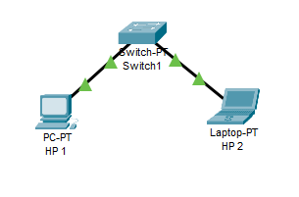

**SWITCH CASE**

**SUCCESSFULLY IMPLEMENTED**

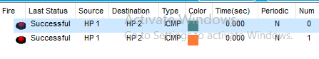

**HUB**

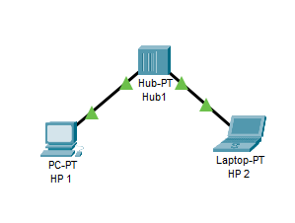

**SUCCESSFULLY IMPLEMENTED**

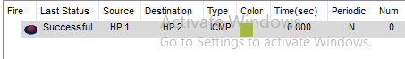

**STAR TOPOLOGY**

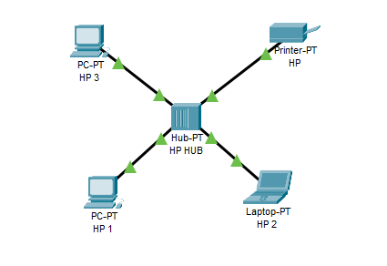

**SUCCESSFULLY IMPLEMENTED**

